**PROJECT REPORT**

**TITLE: ANALYZING THE PERFORMANCE AND EFFICIENCY OF THE**

**RADISSON HOTELS USING DATA VISUALIZATION TECHNIQUES**

1. **INTRODUCTION**
   1. **OVERVIEW**

The Radisson hotel is a well-known international hotel chain that provides high-quality hospitality services to its guests. Radisson owns multiple five-star hotels across India. They have been in the hospitality industry for the past 100 years. Due to strategic moves from other competitors and ineffective decision-making in management, Radisson is losing its market share and revenue in the luxury/business hotels category. As a strategic move, the managing director of Radisson wanted to incorporate Business and Data Intelligence in order to regain their market share and revenue. Our task is to create an analytics dashboard & story to provide them insights to make better business decisions.

* 1. **PURPOSE**

The Radisson hotel is a well-known international hotel chain that provides high-quality hospitality services to its guests. The purpose of this project is to analyze the performance and efficiency of Radisson hotel. The project will examine various aspects of the hotel's performance, including customer satisfaction, employee productivity, and financial performance.

1. **PROBLEM DEFINITION & DESIGN THINKING**
   1. 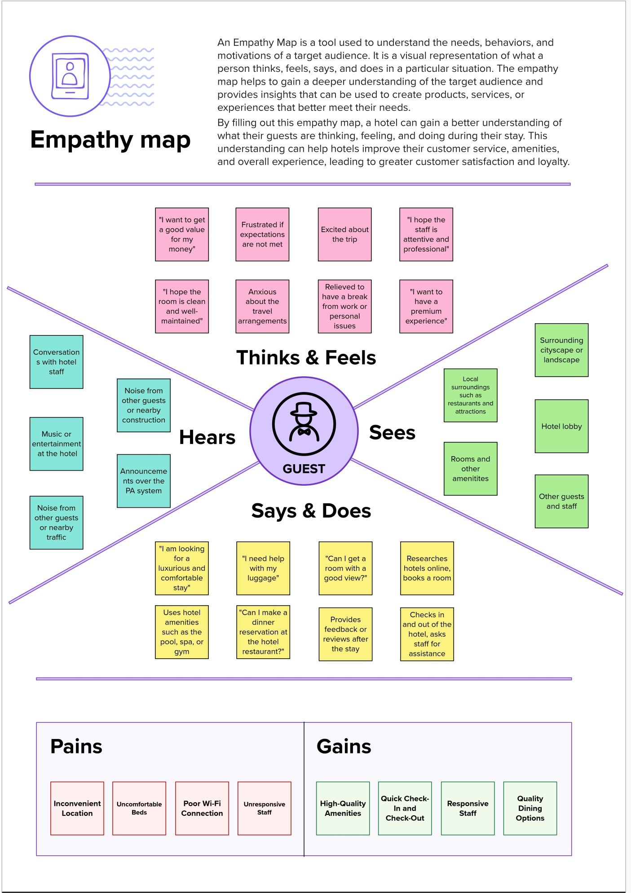**EMPATHY MAP**
   2. **IDEATION & BRAINSTORMING MAP**

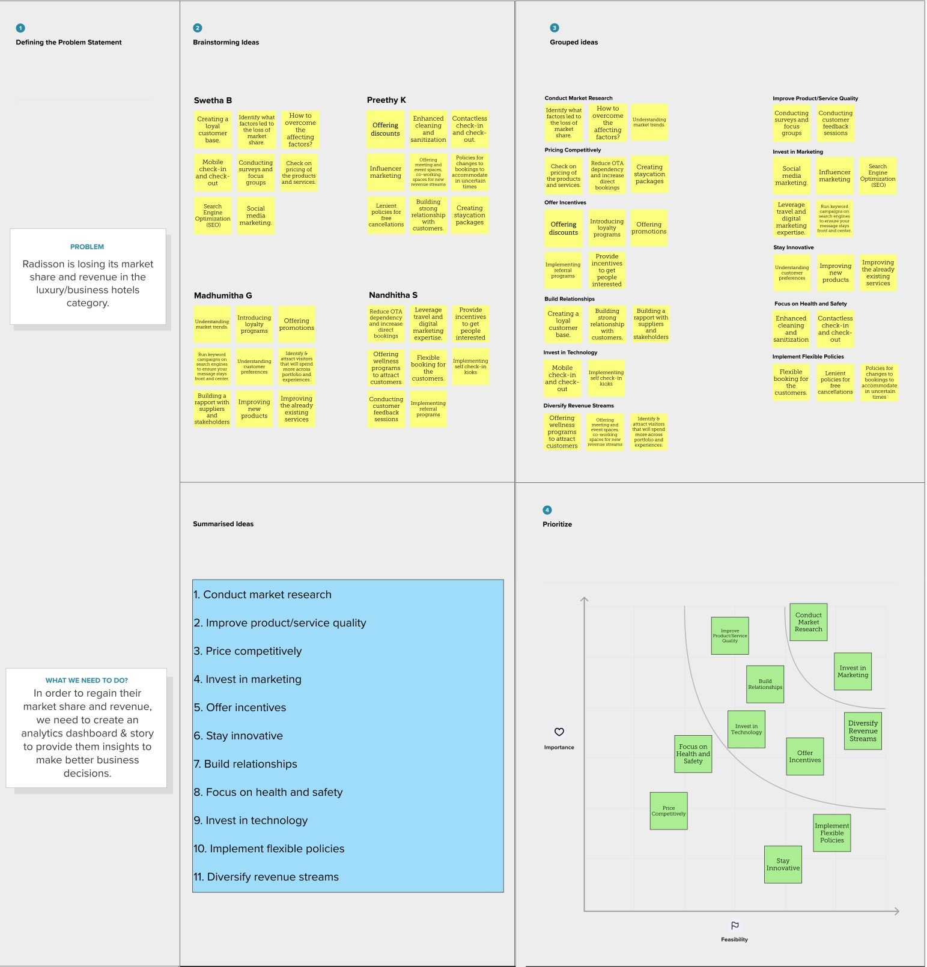

1. **RESULT**

Our analysis revealed that Radisson hotel performs well in terms of customer satisfaction. However, the hotel's occupancy rate is not high as it could be, with an average of 58% throughout the year. The hotel's number of successful bookings is also not as high as it could be, given its occupancy rate. Delhi has the lowest number of successful bookings with 24,231 in number.

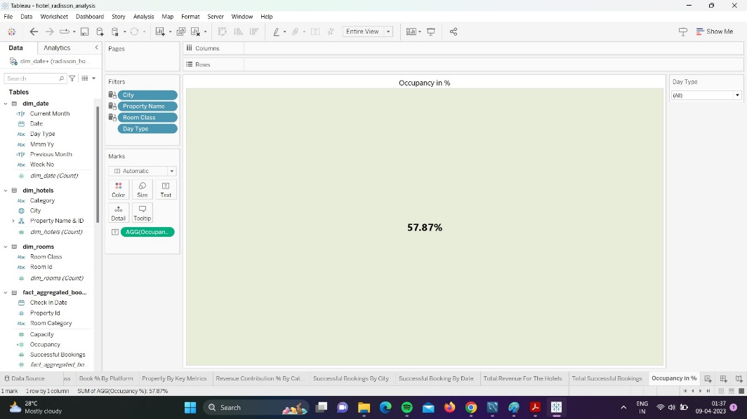

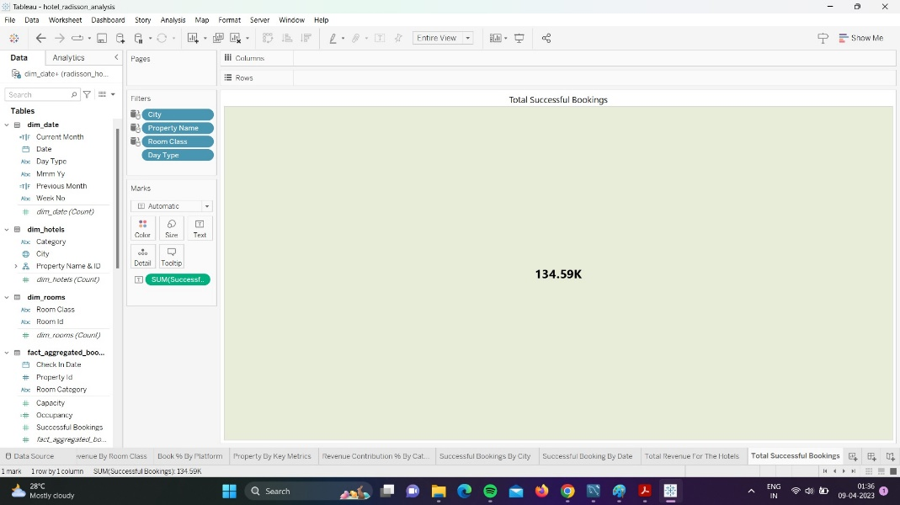

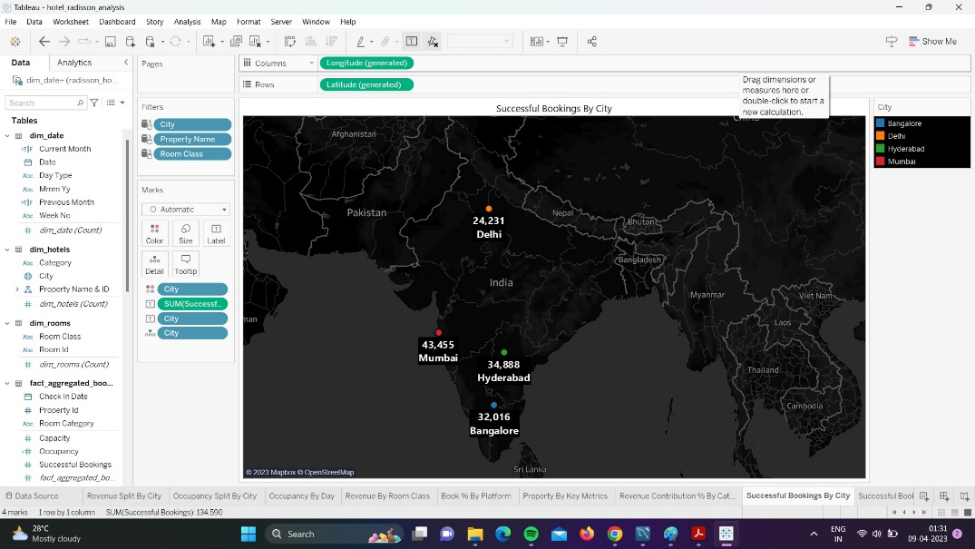

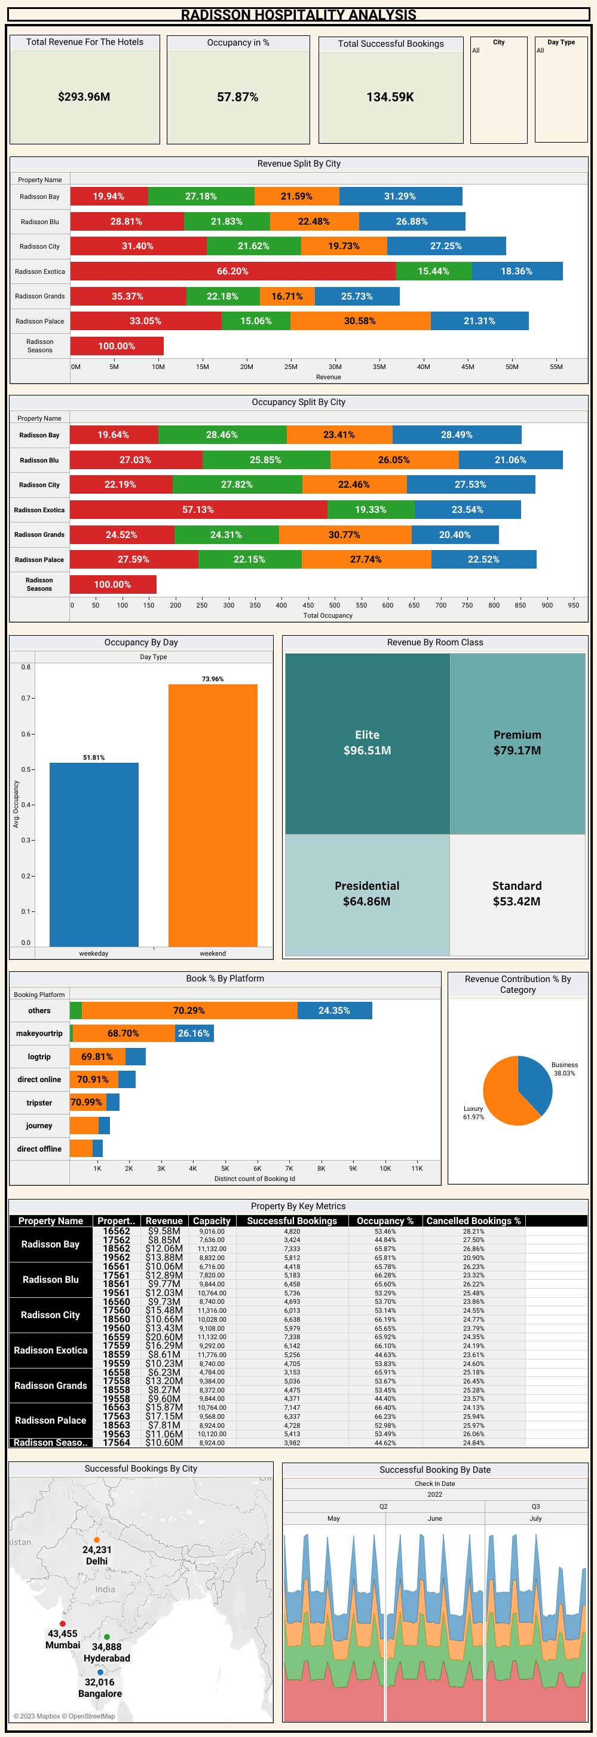

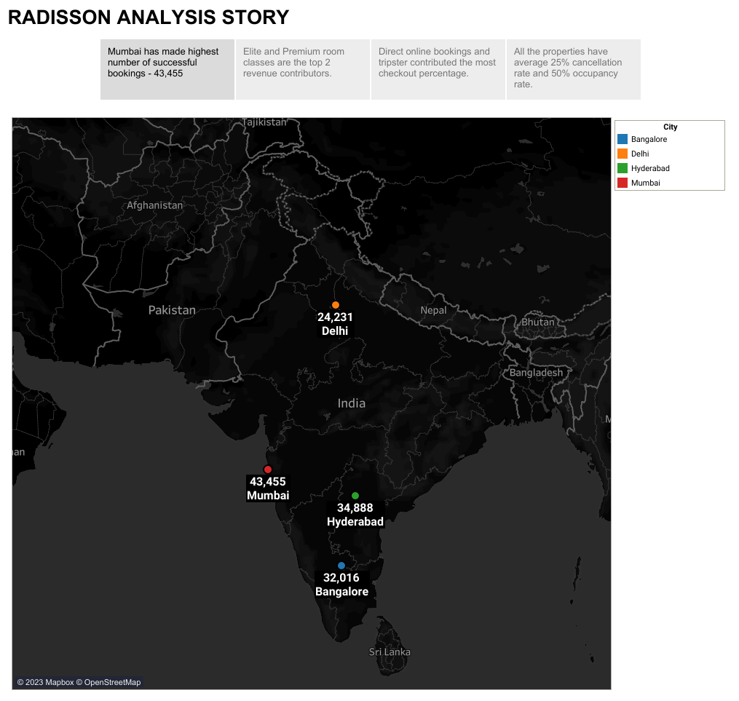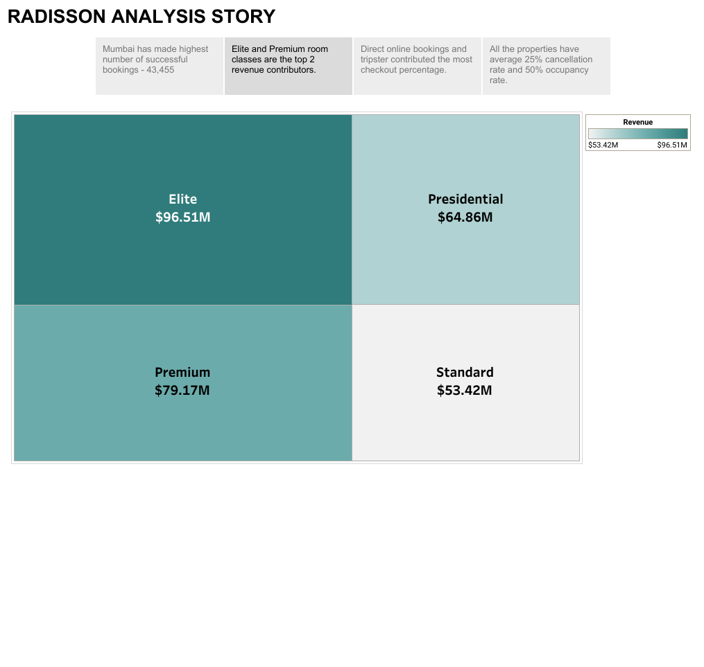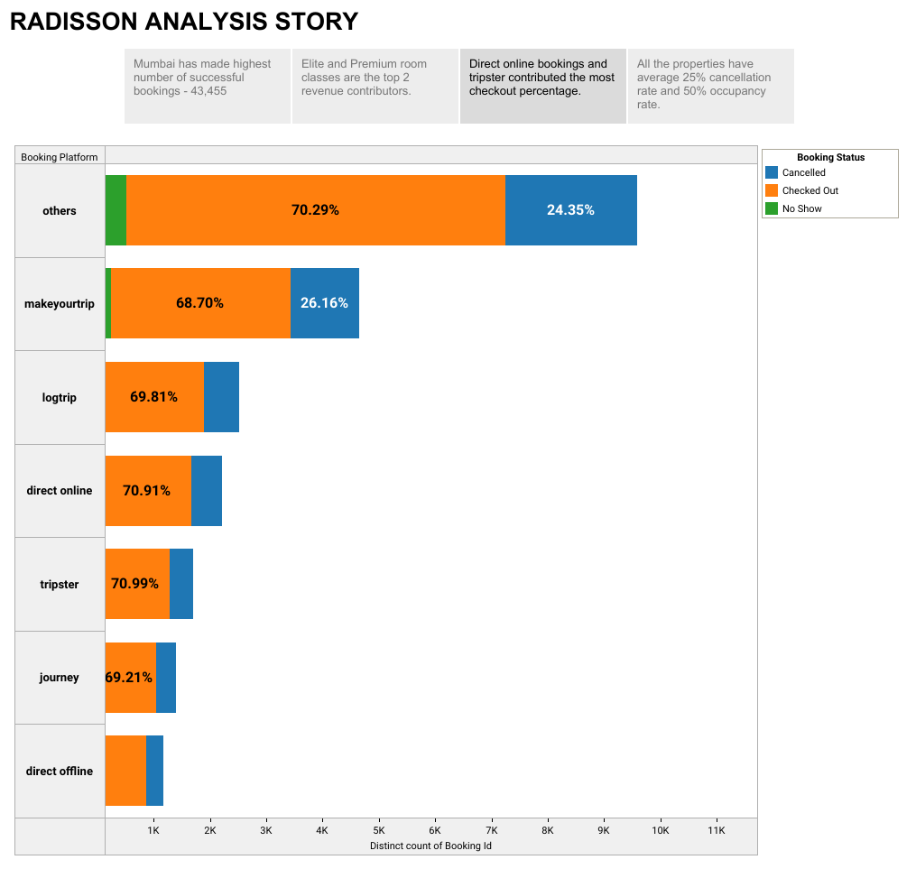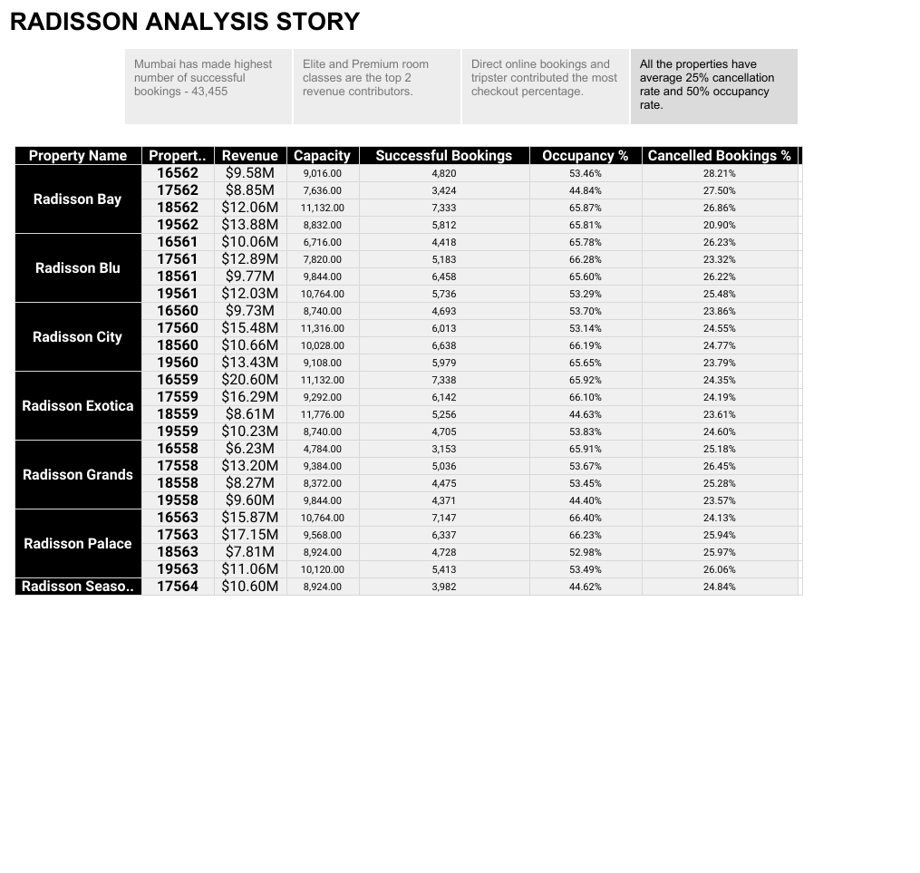

1. **ADVANTAGES & DISADVANTAGES**
   1. **ADVANTAGES**

* Provides insights into the financial and operational performance of Radisson Hotels, which can be helpful for investors, stakeholders, and management.
* Helps identify areas where Radisson Hotels can improve its efficiency and effectiveness, which can lead to cost savings and increased profitability.
* Provides a comprehensive analysis of customer satisfaction and employee satisfaction, which can help Radisson Hotels improve its reputation and attract more customers and talent.
* Can be used as a benchmarking tool to compare Radisson Hotels' performance against its competitors in the hospitality industry.
  1. **DISADVANTAGES**
* Data collected for this report may not be comprehensive, which can limit the accuracy and completeness of the analysis.
* Ratings and reviews on online review websites can be subjective and biased, which can affect the accuracy of the analysis.
* Difficulty in measuring intangible factors such as customer loyalty and brand reputation which can limit the accuracy of the analysis.
* External factors, such as economic conditions and natural disasters, can have a significant impact on Radisson Hotels' performance, which may not be fully reflected in the analysis.

1. **APPLICATIONS**

* By identifying areas where the hotel can improve its efficiency and effectiveness, management can develop strategies to optimize performance and increase profitability.
* The report can be used as a benchmarking tool to compare Radisson Hotels' performance against its competitors in the hospitality industry.
* The report can be used to communicate the hotel's performance and efficiency to investors and stakeholders. This can help build trust and confidence in the hotel's management and increase investment in the company.
* The report can be used to identify areas where the hotel can optimize costs and increase efficiency. This can help reduce expenses and increase profitability, which drives to its growth and expansion.
* By identifying areas where customers are less satisfied, management can develop strategies to improve customer satisfaction and loyalty.

1. **CONCLUSION**

The project will provide a comprehensive analysis of the performance and efficiency of Radisson hotel. The analysis will identify areas where the hotel is excelling and areas that need improvement. The findings of the project will be used to develop recommendations for improving the hotel's performance and efficiency. These recommendations will be based on the strengths and weaknesses identified in the analysis and will be aimed at enhancing customer satisfaction, employee productivity, and financial performance.

1. **FUTURE SCOPE**

* Radisson Hotels can use the insights provided by this report to identify new markets where it can expand its operations.
* Implementing new technologies such as mobile check-in and keyless room entry, as well as investing in digital marketing can improve customer experience.
* Investing in employee training and development programs, as well as offering competitive compensation and benefits packages to attract and retain top talent will improve employee engagement and development.

1. **APPENDIX**

Data set:

<https://drive.google.com/drive/folders/1fJ0rMtr4dCNgMhI8TCUf133sEwHZC3Sc>